Lab Objective /Problem : Creation of Custom BAPI
Transaction Codes : SE11, SE37, BAPI and SWO1

Implementation Steps:
Step #1 : Enter the Transaction code SE11 to create the Structure.
Navigation: Select the Radio button → Data Type→ enter the Structure Name then Create Click on button. Note: Zbapi_strs.

Note: the below Structure name should start with ZBAPI_
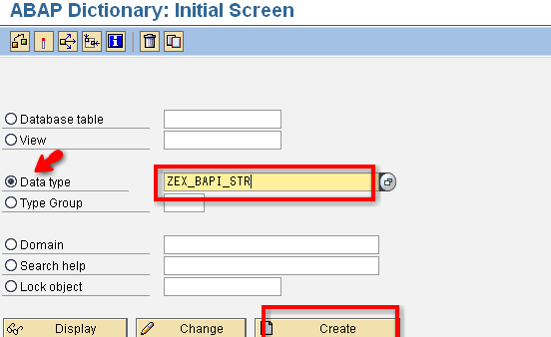

Step # 2: select the Structure and click on the Continue.

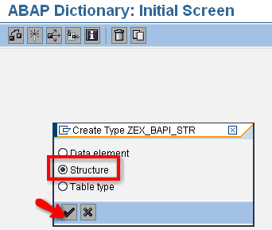

Step # 3: Enter the Description and In the components tab of the structure, give the different fields and their corresponding field types and Press enter and Save the Structure

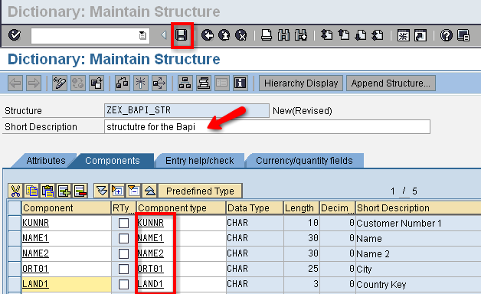
Step # 4: Enter the Package Name and Save it.

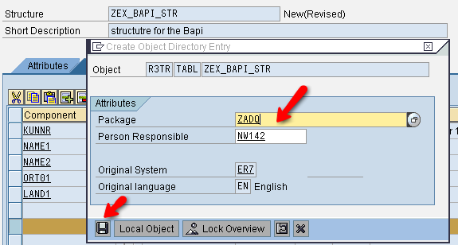

Step # 5: Select the Create Request and enter the Short Description then Click on the Save.
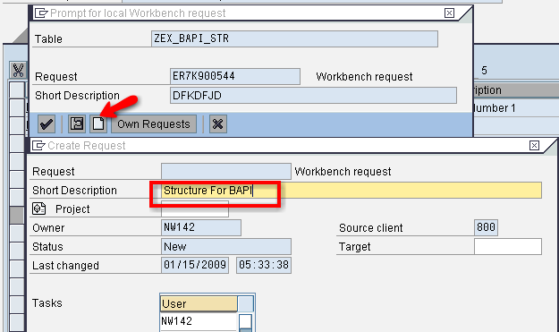
U will get the New Request Number then click on the Continue button.
Step # 6 : Save and Activate the Structure.

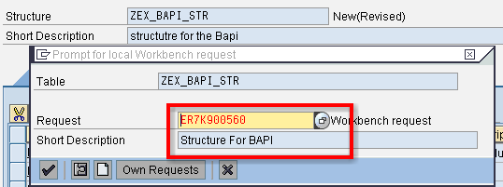

Step # 7: Enter the Function Module name and Click on the Create button.
Note: Fmname : Bapi_any name SE37 T-CODE

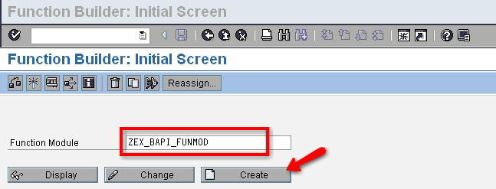

Step # 8: Enter the Function Group Name and Description then Save it.

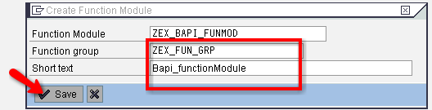

Step # 9: we will get a Plain Function Module then select the Attributes Tab

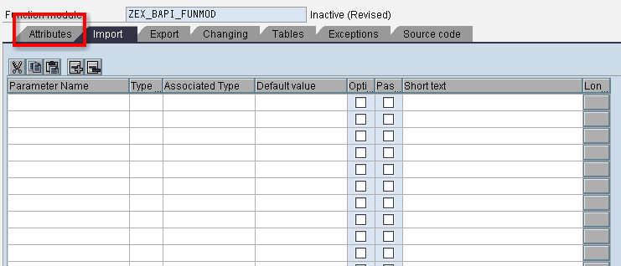

Step # 10: Go to the Attributes tab and select the radio button reading “remote-enabled module”. Come back to the imports tab and provide the import parameters.

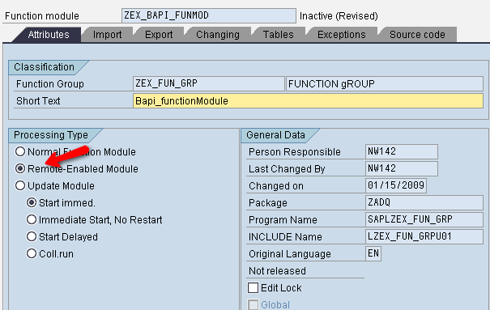

Step # 11: Provide the IMPORT Parameter as KUNNR and its Type (structure type).

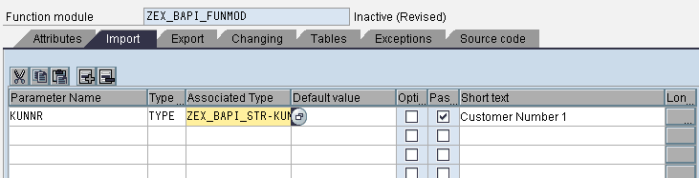

Step # 12: Provide the EXPORT Parameter RETURN and its type as BAPIRET2.

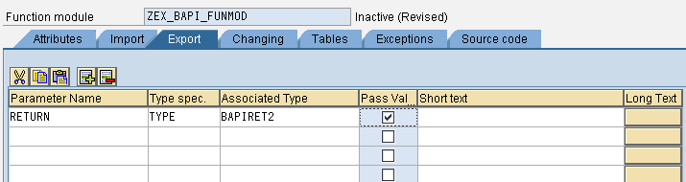

Step # 13: Select the Table Tab
Enter the Parameter Name as IT_TAB and its associated type is Structure type.

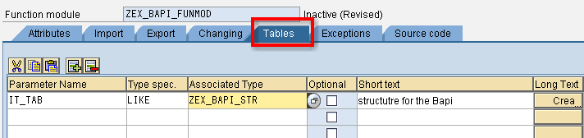

Step # 14: select the Source Code Attribute and write the code.

Step # 15: Save and Activate.
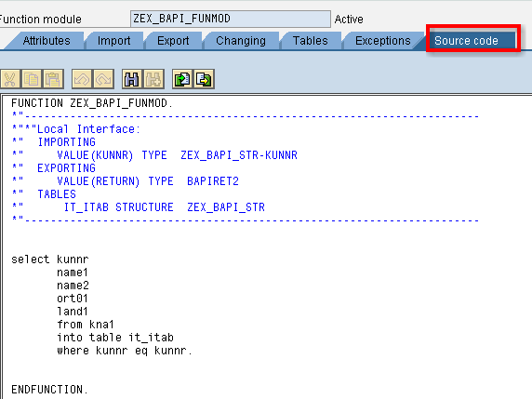

Step # 16: Go to Function Module Initial Screen and Release the Function Module.
Navigation: Function Module → Release → Release.

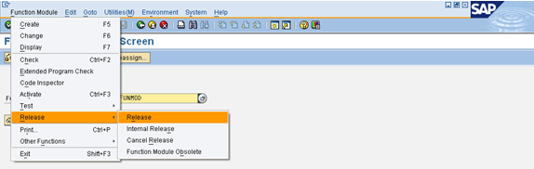

Step # 17: go to transaction code SWO1 and enter the name of the BAPI you would like to create and click the create button.

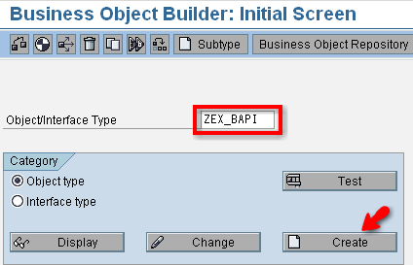

Step # 18: Give the BAPI Object Name and Description and Program Name.

And Provide the Application Name as * (for Cross Applications)
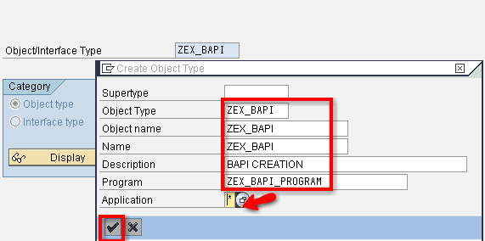

Step # 19: Enter the Package Name and Save.

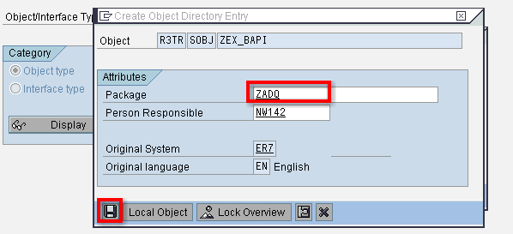
Step # 20: Click on the Create Own Request Number and Provide the Descriptions
And Save.

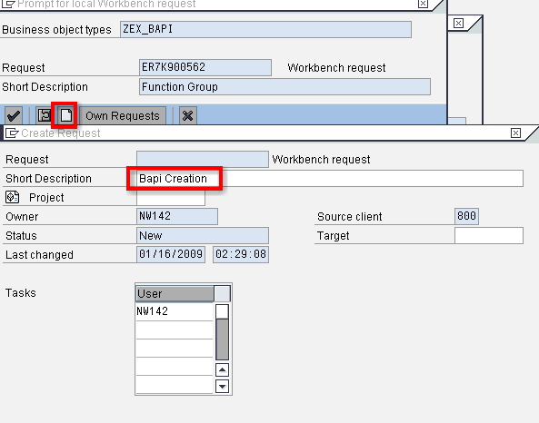

Step # 21: Click on the Methods methods to drop down and two methods are provided by default. There would be two methods, showing in red color which comes by default while creating the BAPI.

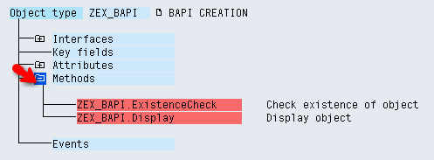

Step # 22: Select the Method and a New Method
Navigation : Utilities → API Methods → Add Method.

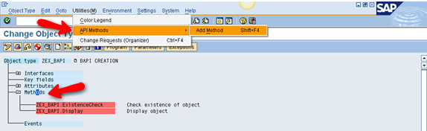

Step # 23: Provide the Function Module Name and Continue.

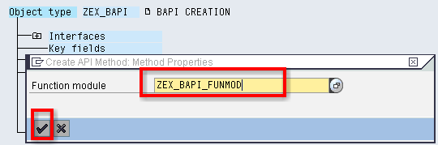

Step # 24: Click on the NEXT Step.
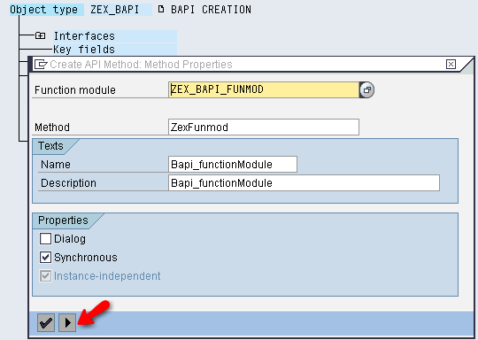

Step # 25: Click on the NEXT Step.

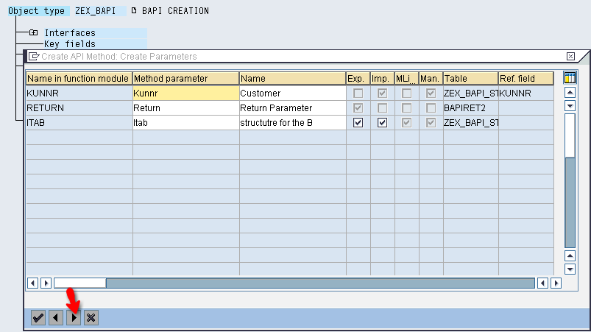

Step # 26: Click On Yes. and Save.

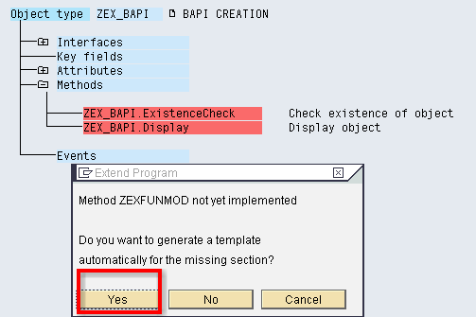

Step # 27: Select API Method ZEX_BAPI.ZEXFUNMOD and Double click o it.
Step # 28: select The ABAP Tab.

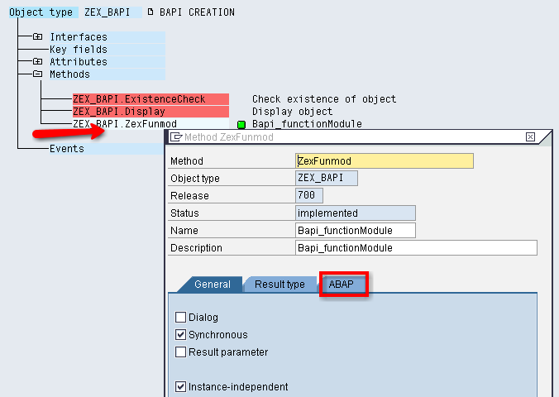

Step # 29: select the API Function radio button and Click on the Continue

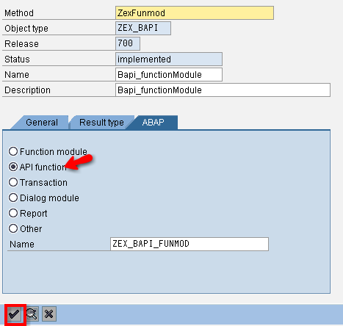

Step # 30: Select the ZEX_BAPI.

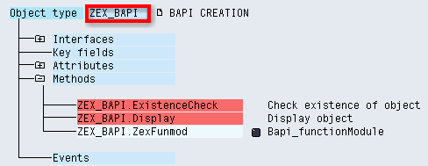

Step # 31: Go to Edit → Change Release Status → Object Type →To Modeled.

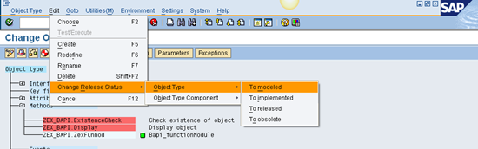

Step # 32:
Go to Edit → change Release Status → Object Type → To Implemented.

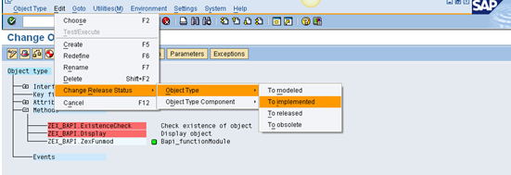

Step # 33:

Go to Edit → change Release Status → Object Type → To Released.

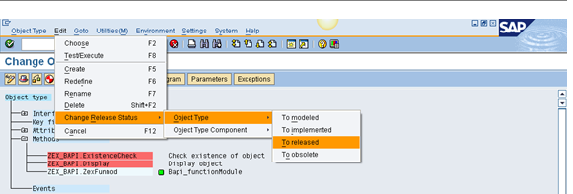

Step # 34: select the Method Zexfunmod.(keep the Cursor on Method)

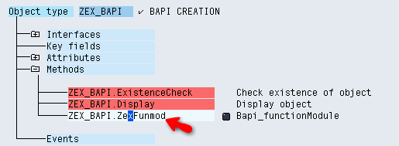

Step # 35: select the Method (zex_bapi.zexfunmod)
And Go to Edit → Change Release Status → Object Type Component → To Modeled .

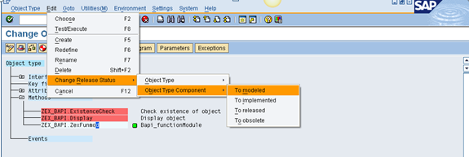

Step # 36: Select the Method (zex_bapi.zexfunmod)
And Go to Edit → Change Release Status → Object Type Component → To Implemented

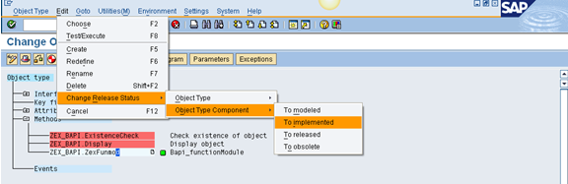

Step # 37: Select the Method (zex_bapi.zexfunmod)
And Go to Edit → Change Release Status → Object Type Component → To Released

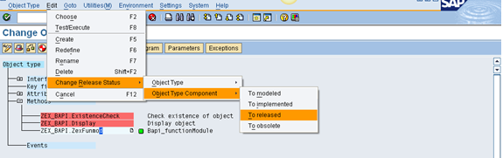

Step # 38: Click on the Generate Button.

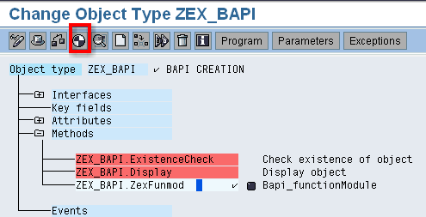

Step # 38: Enter the T-Code BAPI.

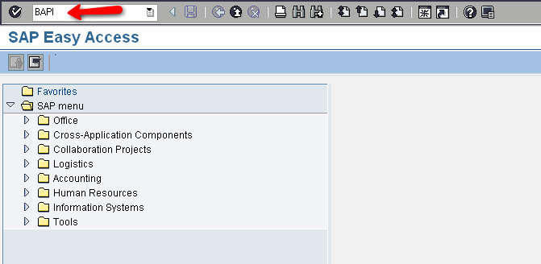

Step # 39 : Click on the Alphabetical and Select the BAPI Name ( ZEX_BAPI)

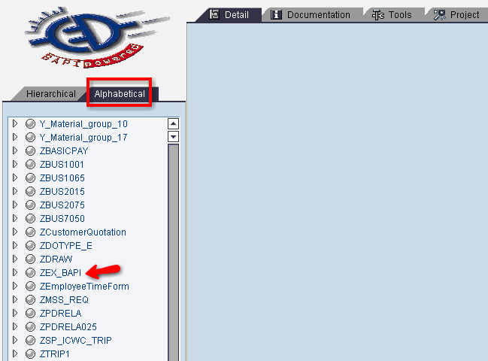

Step # 40:
Enter the Transaction Code as SWO1.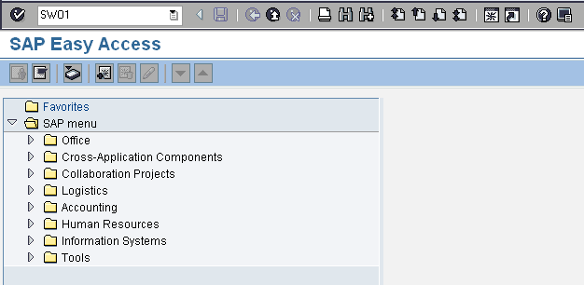

Step # 41: Enter the BAPI Name and Test.

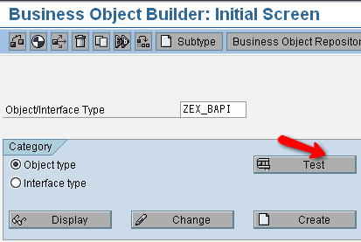

Step # 42: Enter the Kunnr (customer Number)
Then Click on the Entry.

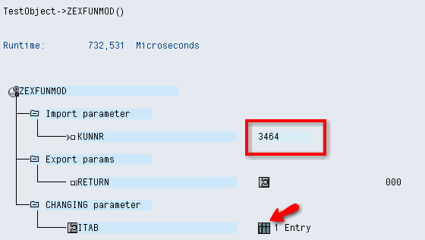

Step # 43: Output.

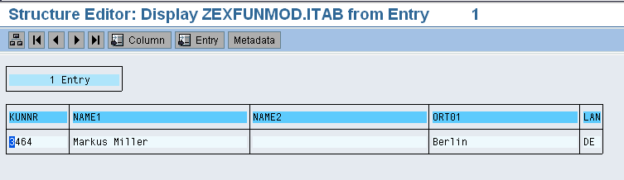

Step # 44 .Create a appliaction program and call the custom BAPI with RFC destintion.

